**HOW TO USE THE WEBSITE:**

When the user opens the website, he will be asked to login with his username and password to authenticate him to park the vehicle inside. On logging in, he will be directed to a page which will show him the vacant, booked and taken by faculties spot counts for 4-wheeler. He can click on either of the spots which will lead to the database being updated with the count changed.

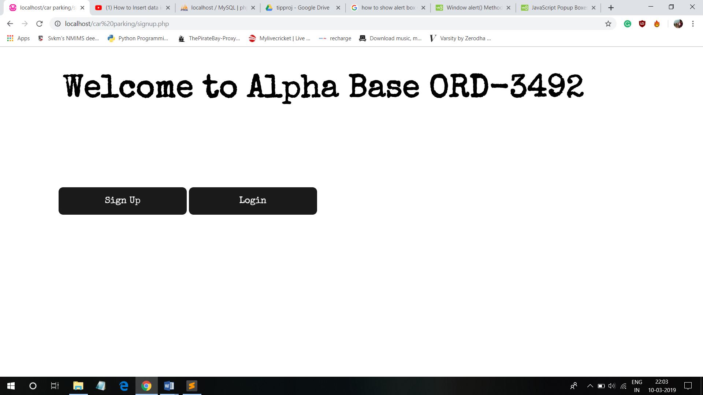

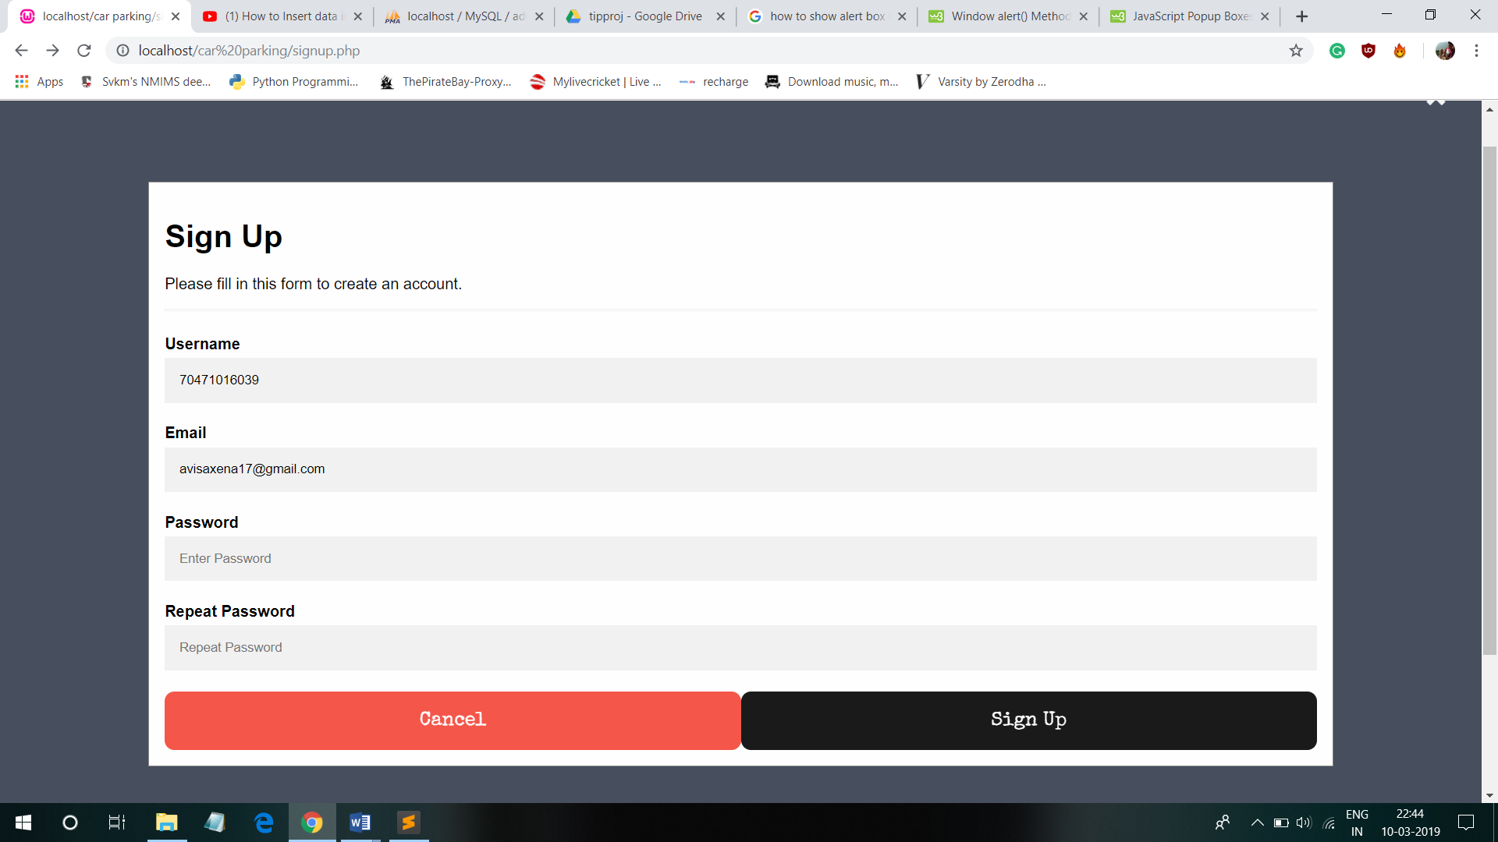

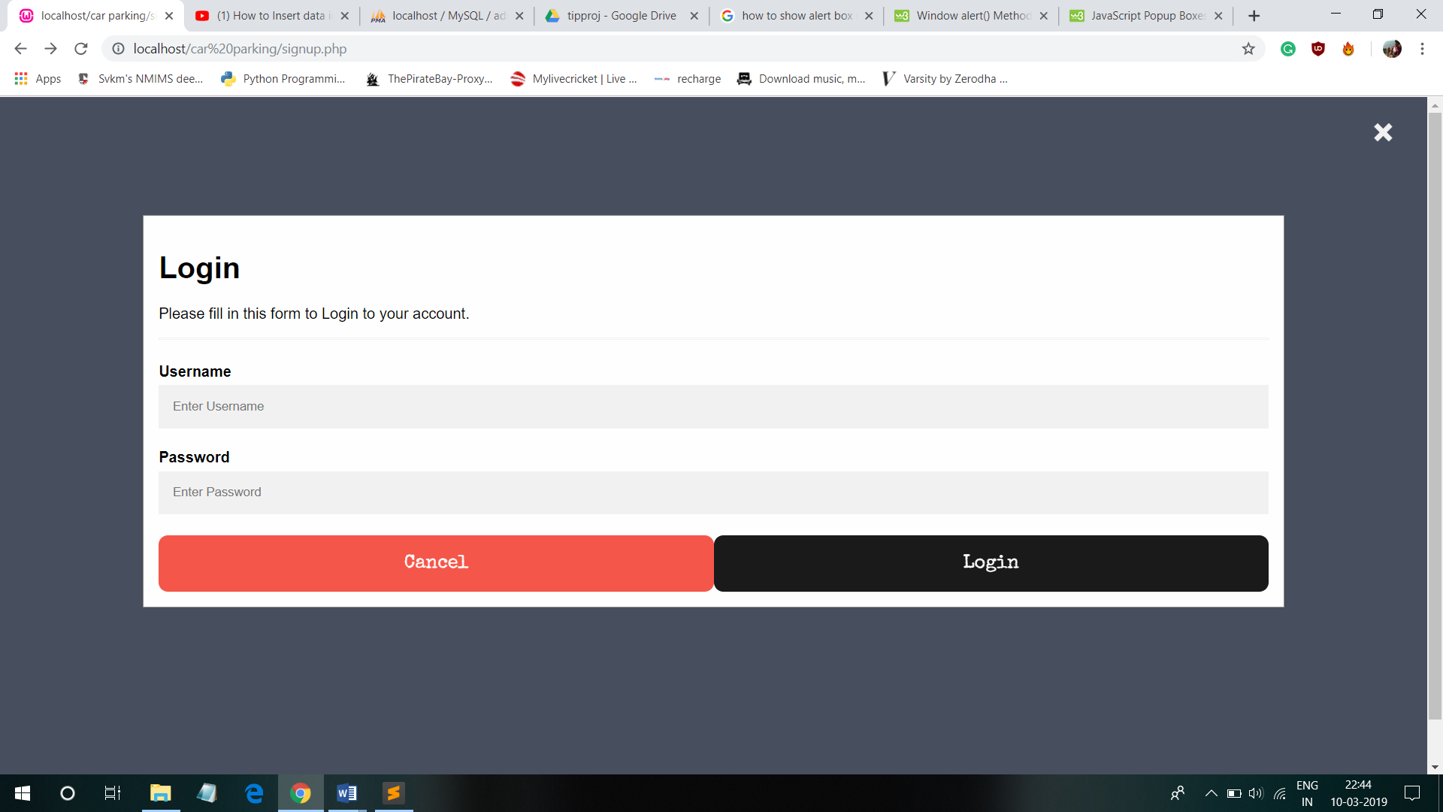

**CHOOSE YOUR PARKING SPOT:**

You will be redirected to a page where you can see the spot and click on it to book it. The red coloured spots are the booked one and the green coloured spots are the available one.

